# Lab 15: Deep Learning Tutorial 5

By Alex Chang, last modified on 05/30 2020.

## Hardware and Software Setup

Access GPU machine with ssh

**laptop $ ssh [username]@140.113.148.xxx**

Type the password then you will see like this

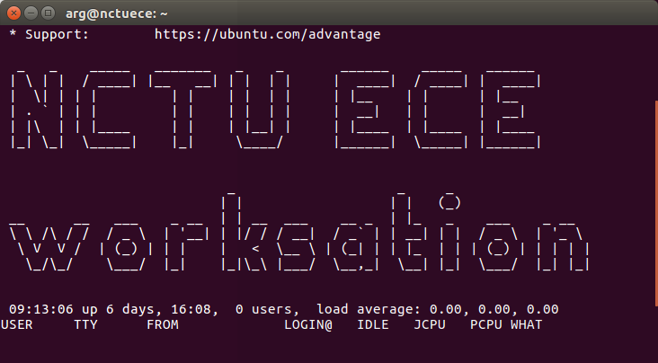-

**ws : workstation**

Clone the course repository

**ws $ cd sis_lab_all_2020  
ws $ git pull origin master  
ws $ git checkout master**

Run the docker and jupyter notebook

**ws $ cd ~/sis_lab_all_2020/15-Deep_Learning_5**

**ws $ source docker_run.sh**

**container $ cd detectron2/**

**container $ jupyter notebook --ip 140.113.148.XXX**

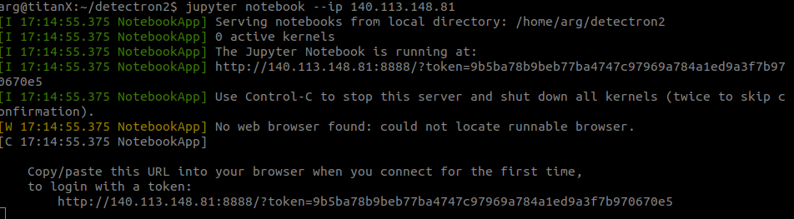

e.g. http://**[workstation_ip]**:**[port]**?token=**[xxxxx]**

Turn on the web browser on local and type the **workstation’s IP** and **token** from above

You will see something like this

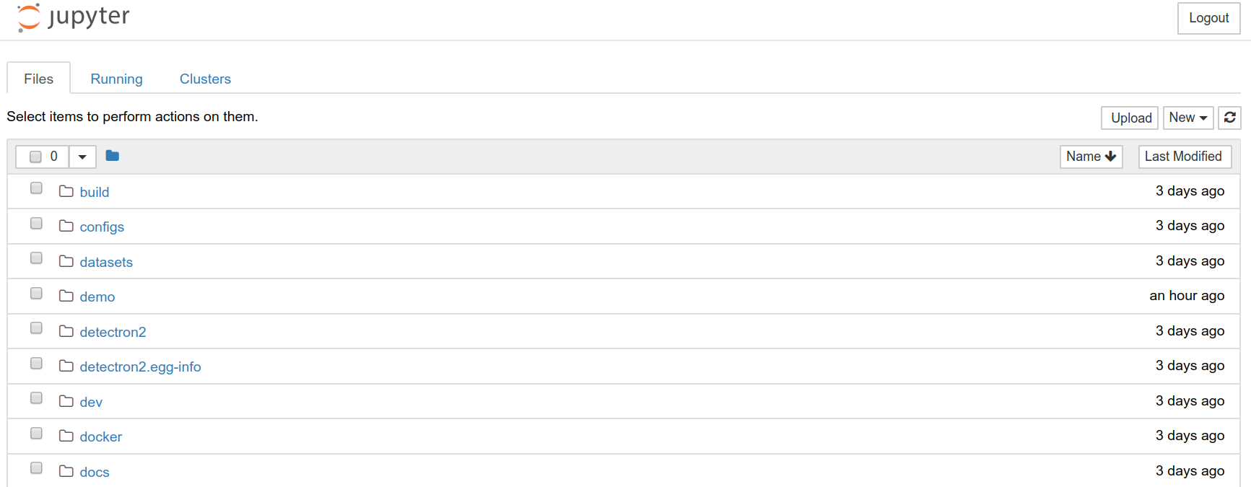

**Lab 15: Deep Learning Tutorial 5** **1**

Hardware and Software Setup 1

Overview 2

Topics and Activities 3

Topic 1 Pytorch-MaskRCNN 3

Assignment Tasks 4

Reference 4

## Overview

Estimated Time to Finish: 1 hour

After completing this tutorial you should

* Know the complete process to load, train data, and evaluate your model with test data.
* Understand how to use the Jupyter notebook.
* Understand how MaskRCNN works.

## Topics and Activities

### Topic 1 Pytorch-MaskRCNN

When turning on jupyter notebook into the **datasets** folder, and click **Download_dataset.ipynb**

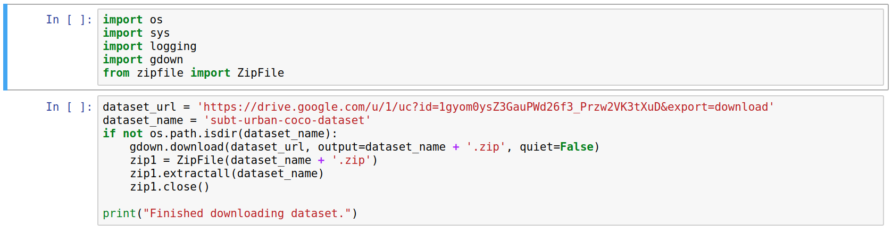

After executing that, you will get the **SubT-dataset**.

Into the **tools** folder, and click **train-MaskRCNN-SubT.ipynb.**

Then you can start to train and predict images.

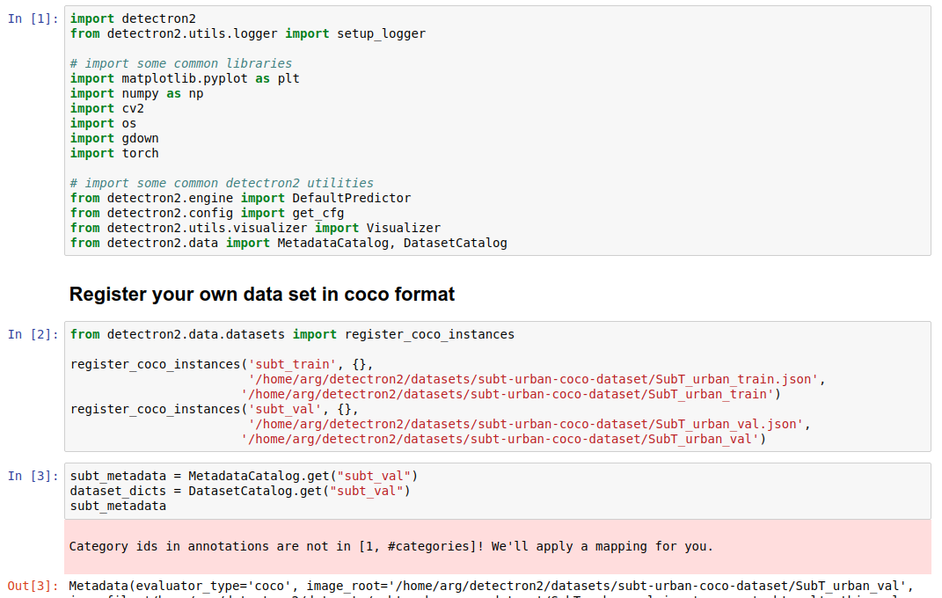

If you want to evaluate the model and predict videos, click **evaluate-MaskRCNN-SubT.ipynb**

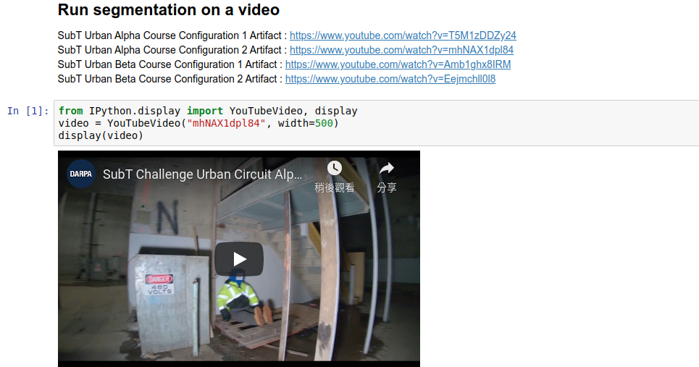

Discussion

1. Explain the problem of ROI pooling in MaskRCNN.
2. Briefly describe the concept of ROS align.
3. Try to explain the structure of Mask-RCNN.
4. Try to explain if you want to train sis competition dataset, what are you going to do?

(Example : convert VOC to COCO format, register_coco_instances …..)

## Reference

Pytorch official tutorial: <https://pytorch.org/tutorials/>

Mila-udem pytorch tutorial: <https://github.com/mila-udem/welcome_tutorials/tree/master/pytorch>

facebookresearch/detectron2:

<https://github.com/facebookresearch/detectron2>

VOC2COCO

<https://github.com/thpss92093/voc2coco>